Tendency Based Golf

While golf swing “experts” have attempted to break down and understand the golf swing at a nano-particle level, little has changed in the scores or ball striking of the average golfer. Information overload, and more importantly, conflicting information overload is partly to blame. The biggest reason that golf instructors and swing analysts have failed is because they have insisted on trying to make the golf swing fit their idea of a model or mold. They end up having to make broad generalizations that end up being nothing more than a compromise and attempt to classify something that just has too many variations. Just about every well known golf instructor has attempted to create his or her swing model that he or she attempts to mold a golfer into. Others have gone a new route and tried to base the golf swing on body type, but again, these end up being nothing more than generalizations because maybe 1 in 100,000 golfers perfectly fit their build model. None of these ideas have worked across the board because they are trying to put a round peg in a square hole when common sense tells us to put a square peg in a square hole. To make the pieces fit in their correct hole by explaining not how one must fit into a mold, rather, I will explain how tendencies cause certain types of shots and dynamics in the swing. In doing so, I will work with the primitive idea that there are, in essence, two basic types of golf swings – a rotational swing that tends to be more around and an upright swing where the club will tend to stay more in front of the body. If you are familiar with Jim Hardy’s ideas of a one a two plane swing, you will see similarities in the two basic ideas of a golf swing and may use that as a basis for the two primitive swing types. However, understand that you are not limited to Jim Hardy’s ideas of two swing types, but all instruction models are governed by the rules of tendencies. If you have studied David Leadbetter for year or Butch Harmon, both of their ideas of the swings will produce tendencies that a golfer can minimize by a simple explanation and understanding of what causes them.

ten·den·cy (tndn-s)
n. pl. ten·den·cies
- Movement or prevailing movement in a given direction: observed the tendency of the wind; the shoreward tendency of the current.
- A characteristic likelihood: fabric that has a tendency to wrinkle.
- A predisposition to think, act, behave, or proceed in a particular way.
Like all things in golf, there are few hard and fast rules that are unanimous across the board, that is why I use the word tendency as defined above. It is something that prevails or is a trend, but does not mean that this is the only way. Any golfer can take one of these tendencies and manipulate their body or club in such a way to “override” their tendency. I’m fine with it, as long as they do it consistently. That then makes their tendency a trend of overriding a common tendency. These tendencies are based on my years of work and study with golfers of all abilities, from playing professionals who have played on the PGA Tour to the average amateur, to other brilliant swing coaches who I have had the opportunities to work with. They are also things I have experimented with and learned over 15 years of playing competitive and professional golf myself. They are things that I have seen over and over again enough times to realize a commonality or trend that causes the behavior. One thing you will note in my teaching is that I don’t require a golfer to fit into any one person’s mold or swing philosophy, but I will use the basic ideas of a more upright swing versus a rotary swing, while allowing for more flexibility within those guidelines. While it has been stated that it is a disaster to combine traits of the two swings, it is obviously not true. If you’ve ever been to a PGA Tour event you can easily see that nearly every single golfer is a “hybrid” or blend between the two swing types. It’s not that I’m encouraging someone to combine the two models, but the simple fact of the matter is that as people find a consistent way for them to swing the club for their body and ability, inevitably combinations occur and it is perfectly acceptable. It is not important what pieces you combine in your natural golf swing, it is simply important to understand the tendencies that they cause. While I’m all for a golfer trying to maintain more traits of one swing over the other, it simply doesn’t happen, particularly at a professional level, for a reason. If you find that things don’t feel natural for you but doing something that doesn’t fit the model does and you can consistently and solidly strike the ball, then don’t fight it, simply understand the tendencies that it will cause and move on. I have had the opportunity to work with and talk to many professional golfers and one common theme has occurred between them all, very few have a clue how they swing a golf club. They may have one or two simple things that they know they do, but beyond that they don’t want to know and don’t care. I spent some time working with a friend of two time US Open winner Lee Janzen in 2005 and asked him what Lee was working on in his swing. He told me that Lee had said the exact same thing and nothing else for the past several year; “I’m working on turning my hips as hard as I can. That’s it. I think of nothing else.” While I’m sure Lee has a more in depth understanding of the golf swing than just turning the hips, I can assure you that it pails in comparison to the wealth of useless and conflicting information the typical “armchair golfswingaholic” has in his mind. The typical double digit handicapper has read more books on swing theory than many teaching professionals and yet they can’t break 80 to save their lives. Less is more in many ways in golf and flexibility within swing models is the rule rather than the exception. Before we embark on this final journey in your understanding of the golf swing, I ask that you do me one favor. Go out to a quiet driving range and without thinking one single thought about what you are doing, hit balls into you begin to hit them well with no thoughts. If it feels better to stand open, stand open; closed, stand closed. When you begin hitting consistent and solid golf shots, put your swing of video tape and take a look at it. If you are into studying the golf swing, study that swing and see what tendencies you truly have when you let your body do what it naturally wants to do and allow it to hit the ball properly. Now, take note of your ball flight, was it left to right, right to left, were they flying low? Take these traits and study the tendencies you will find within. If your ball flight needs changing, I imagine you will find some information that will help you straighten it out within that still allows you to swing in a natural way for you.

The Address Position

Golfers who make a more rotary type swing where the club tends to swing more around the body can tend to setup with their spine more vertical and their shoulders more level. However, you can also see rotary swingers who will setup with their spine tilted several degrees away from the target and the right shoulder a bit lower. What tendencies does this cause?

More Vertical Spine vs Tilted Spine Away from the target:
A more vertical spine will cause the golfer to tend to do several things:

a) The golfer will tend to take the club more immediately to the inside and have less lateral movement, if any, away from the target during the takeaway.
b) The club will more immediately come off the ground because there is no lateral shift away from the target that would allow the club to be taken away “low and slow” as you may have heard so many times. This lateral shift allows the golfer to “drag” the club back low during the very early stages of the takeaway and keep it moving more on the target line.
c) A more vertical spine gives the golfer a sense of being more “on top of the ball” at address rather than being setup more behind it. Many golfers like this feeling as it provides a sense of confidence that they won’t have any troubles returning the club back to the ball at impact.
d) The golfer with a more vertical spine will tend to have his weight more evenly distributed. The golfer with a tilt in his spine may have slightly more weight on the back foot at address, particularly with the longer clubs, but can offset this by “bumping” the lead hip toward the target at address, setting the left hip somewhat higher than the right but moving more weight to the front foot.

Rotary Swing with Tilted Spine

a) A rotary swinger who tilts his or her spine away from the target at address will find it necessary to make a slight bump of the hips toward the target during the transition in order to get them more “on top of the ball” at impact.

The Takeaway
In the takeaway, I am primarily concerned with two things: the plane the club travels back on and the angle of the clubface. The most common things I see with rotary swingers during the takeaway is a club that is very beneath the shaft plane at address, a clubface this is fanned open by the rolling of the wrists and a clubhead that is well inside the hands when the club reaches parallel to the ground caused by an overactive rear hinge of the right wrist. These three moves that happen very early in the golf swing throw the club off plane and cause many tendencies.

- The first tendency is for the golfer to lose his spine angle at the top of the swing because the momentum and weight of the club traveling so far around and behind the golfer pulls him slightly off balance, so he will raise his spine angle slightly in order maintain a balanced position. From here, golfers can go one of two directions. The first will be that the golfer will lift his arms high above his head to “complete” his backswing and then tend to come down on the ball very steeply. All sorts of misses are possible from this position, from hard pulls to the left to week slappy blocks to the right. The second direction I tend to see in the better golfer. They will tend to keep their spine angle in this position and begin to swing their arms down and more out in front of their bodies. If they clear their lower body aggressively, they will tend to come at the ball more from the inside because of the low club position and hit shots that start to the right and draw back to the target. The divots will face slightly out to the right of the target. The tendency for this golfer is to miss shots to the left when the release of the hands get flippy and overactive.

The fix for either golfer is to work on taking the club back with more passive arms and hands. The first golfer needs to work on swinging their arms more across their body rather than lifting them high above their head. If they cannot do this and continue to end up with a very upright position at the top of the swing, they should develop a shallowing motion to allow for the arms to drop back down on plane during the first half of the downswing. For the second golfer, this will keep the hands from releasing so aggressively through impact. Because they have a tendency to hold on to the club too tightly, they will tend to bring the club back too far inside early on because the tension in the hands and forearms causes them to be overactive and will only increase as the swing progresses toward impact. Soft and quiet hands will allow this golfer to swing through the shot with a more passive release from the hands, providing a straighter ball flight and shallower divots.
- For a golfer that has more spinal tilt at address, the right arm will tend to need to be a little more active to begin pulling the left arm into the body earlier on in the swing. Because of the exaggerated spinal tilt, the arms will hang further away from the body at address, therefore they will need to be pulled in somewhat actively by the right arm bending up along the side of the body, similar to the action of starting a lawnmower. For the golfer who does not have as much spine tilt at address, this action is not as dramatic and will feel a bit more natural, but the same motion in miniature can occur. If this “lawnmower action” does not occur and the arms don’t actively lift the club (which is undesirable in a rotary swing), the club will swing back very low and inside and tend to get too far behind the golfer.

Fundamental Keys for the Takeaway
Quiet Hands
The golfer should keep the arm and especially the hands relatively quiet during the first part of the swing. Far and away the most common swing fault I see is someone whose right wrist begins to hinge backward, pulling the club inside and behind the hands very early in the swing. This becomes a difficult position to recover from on a consistent basis because it requires a timed release of the hands at impact. If the golfer practices imagining their hands are in a cast for the takeaway, this will help them with a mental image of keeping the hands quiet.

Right Elbow
The right elbow should work slightly back, similar to starting a lawnmower in this part of the swing. Ideally when the club reaches parallel to the ground, you have some bend in the right elbow compared to an upright swing takeaway where the arms would both be straight and extended away from the body. This extension of the arms and club away from the body is what creates extra width in the two plane swing and keeps the club in front of the body.

The Club
When the club reaches parallel to the ground, it should be pointing toward your target and still be just outside or inline with your hands. If it begins to travel behind your hands at this point, try and keep it inside your right hip. The better golfer can play fine golf from this position, but it will tend to cause shots that work from right to left as the swing path on the way down will be somewhat more in to out. The most common tendency I see during the takeaway is for the golfer to get the club way too far behind their right hip during this point of the swing.

In the side by side shot below, you can see the two extremes. In the picture on the left, the clubhead has traveled back behind the hands but is still inside the right hip when the club is parallel to the ground. This is perfectly acceptable as long as the tendencies are understood and this position can be repeated by the golfer on every swing. In fact, Ben Hogan and Sam Snead both got the club behind their hands during this stage in the swing. On the right hand side, you can see a golfer who has taken the club away with a very handsy action that has pulled the club away dramatically to the inside. This is a difficult position to play from consistently for the average golfer. It will typically require the golfer to have a very handsy, active release through impact to square the clubface, rather than the more desirable and repeatable passive release where the arms and hands do nothing. Golfers who take the club this far to the inside will tend to either hit very big hooks or blocks, or they will come down steeply from the top and pull cut the ball.
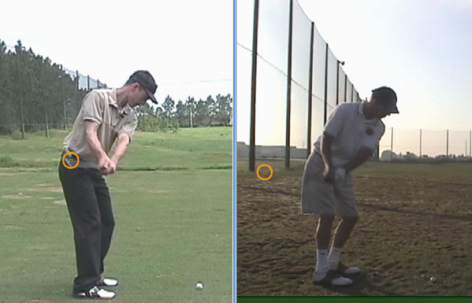

In the picture below, you can see that both Ben Hogan and Sam Snead let the club get behind their hands during the takeaway, Snead more so than Hogan.

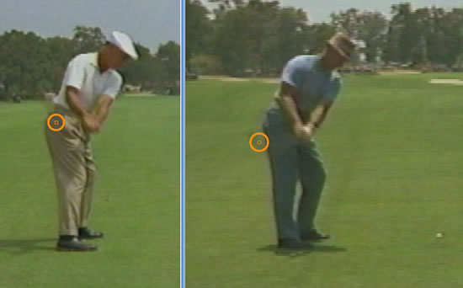

To further illustrate this, study the photos below. During this phase of the takeaway, the two golfers are in very similar positions. Both have swept the club away abruptly to the inside and have the club well behind their right hip. However, from here, they take decidedly different paths to get the club back to the ball and they illustrate perfectly the two most common tendencies from this takeaway position.

To complete the backswing, the golfer on the left will lift his arms high above his head to get in a position that feels powerful. This will, in essence, put him in a classic two plane position at the top with the club directly above the right shoulder and high above his head. The golfer on the right properly relies on more rotary power rather than lifting his arms and continues to swing the club around his body rather than up. At the top, he ends up in more one plane position and this is what differentiates their downswing approaches to the ball that you can see in the next set of photos.

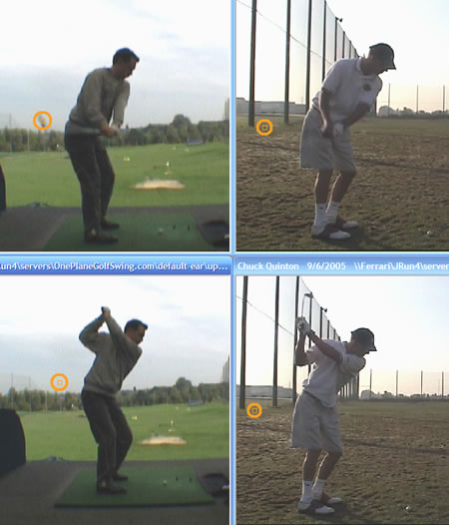

As they start their downswing, the golfer on the left gets the club very steep. He is standing too close to the ball which has also affected his entire swing and will cause him to have a very steep swing path to get back to the ball. The golfer on the right has given himself more room to swing the club around his body.
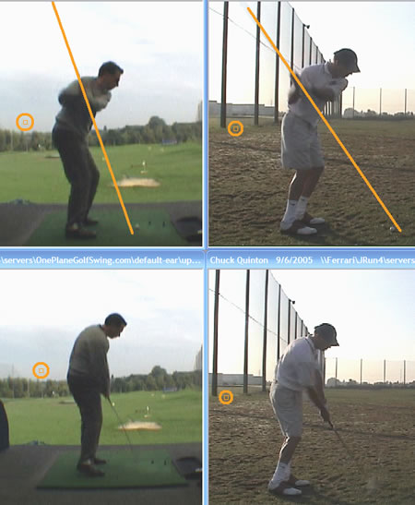
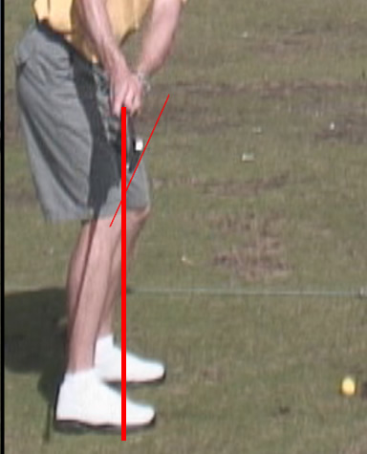

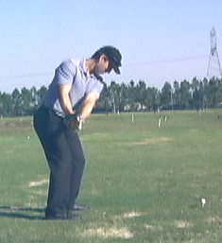

This takeaway position puts the golfer’s left arm into his body and the club is inline with his hands. Also note that the right elbow is beginning to hinge up and behind him rather than being extended straight. Even more bend in the right elbow is acceptable here as it will reduce width in the swing and help the club begin to work back more to the inside.

